**Assignment -4**

News Tracker Application – Kubernetes / Docker

|  |  |
| --- | --- |
| Assignment Date | 20 October 2022 |
| Student Name | PRINCE VASANTHARAJ R |
| Student Roll Number | 953719104043 |
| Maximum Marks | 2 Marks |

**Question-1:**

1. Pull an Image from docker hub and run it in docker playground.
2. Create a dockerfile for the job portal / flask application and deploy it in Docker desktop application.
3. Create a IBM container registry and push docker image of flask application or job portal app.
4. Create a Kubernetes cluster in IBM cloud and deploy flask application image or job portal image and also expose the same app to run in Nodeport.

**Solution:** \*\***All the required files are uploaded in the Assignments/Prince Vasantharaj R (Team Lead)/Assignment 4 folder in the Git repo. Please verify it sir/mam.**

**Step 1**: Pull an Image from docker hub and run it in docker playground.

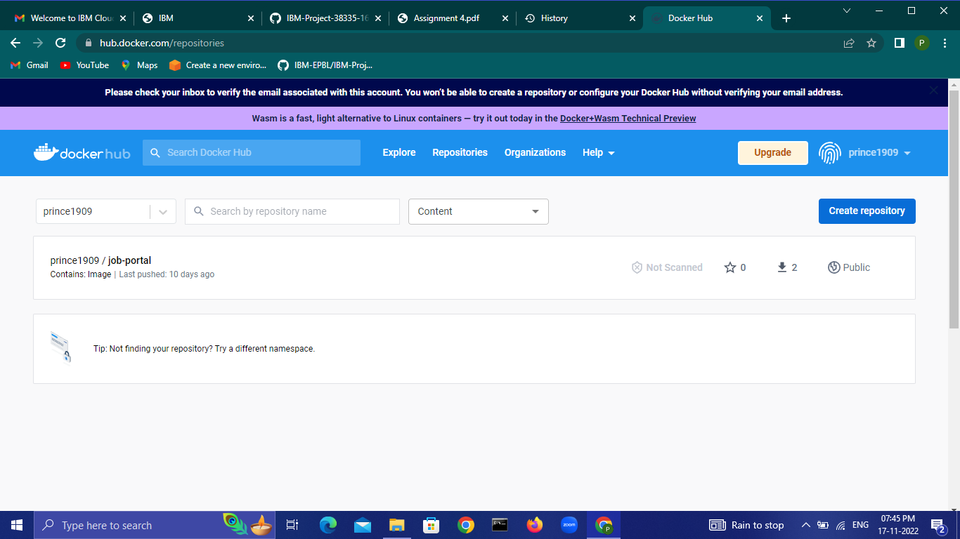

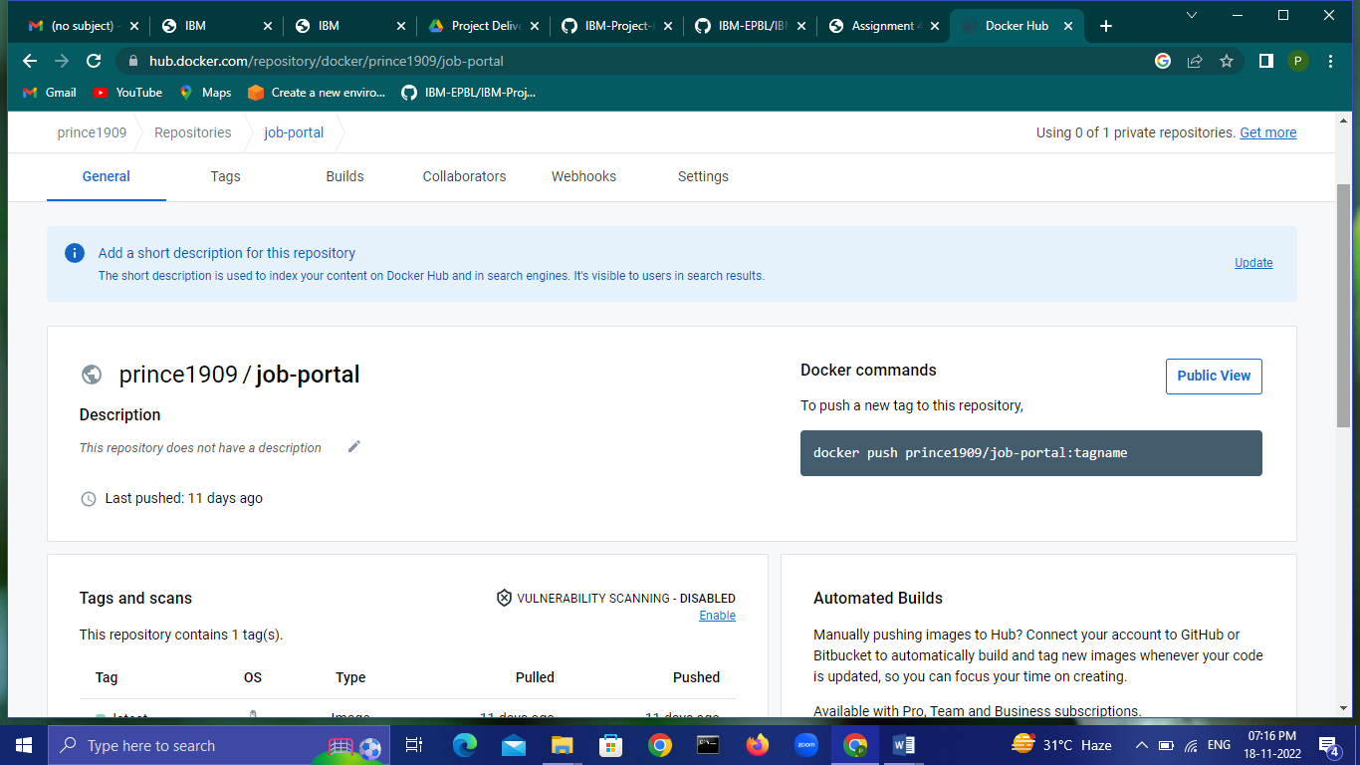

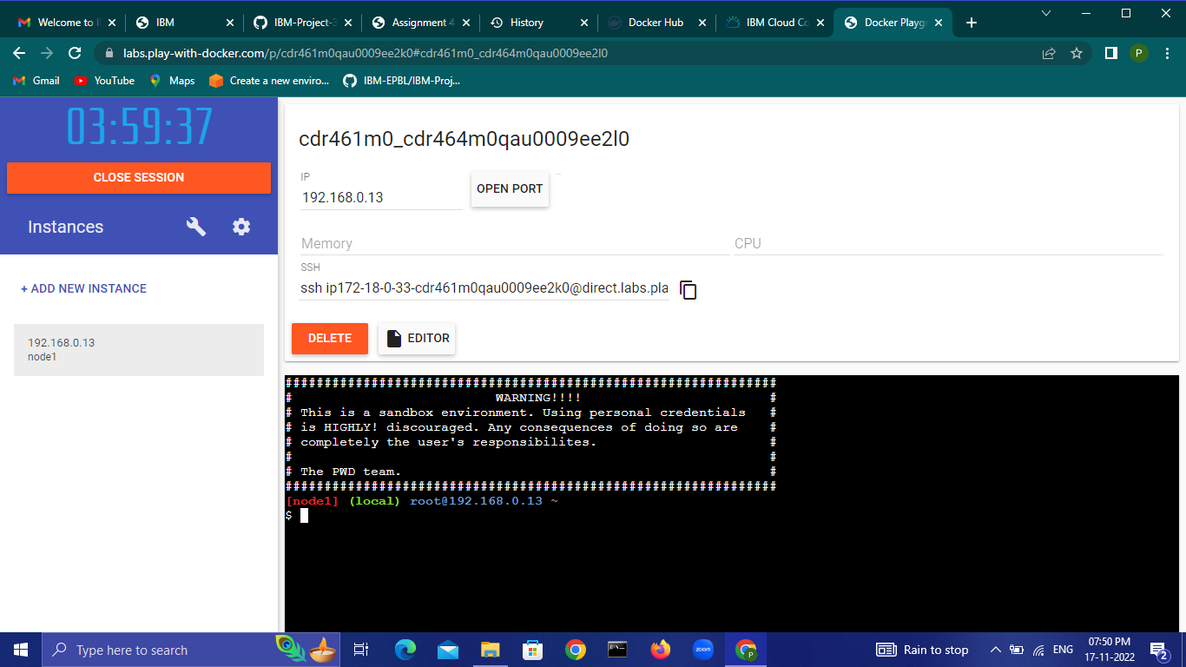

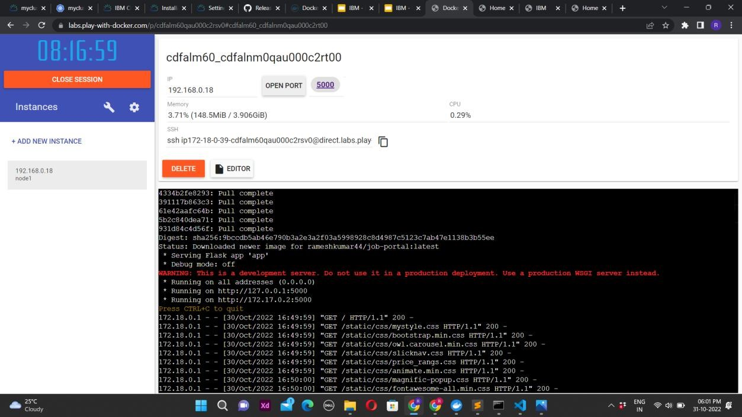

**Step 2**: Create a dockerfile for the job portal / flask application and deploy it in Docker desktop application.

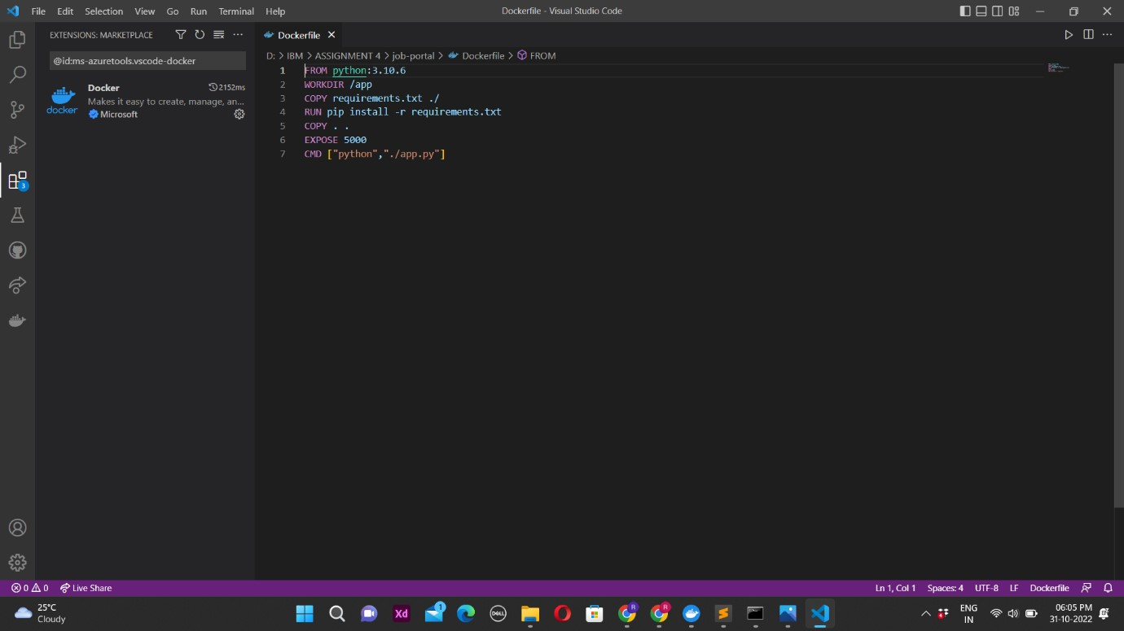

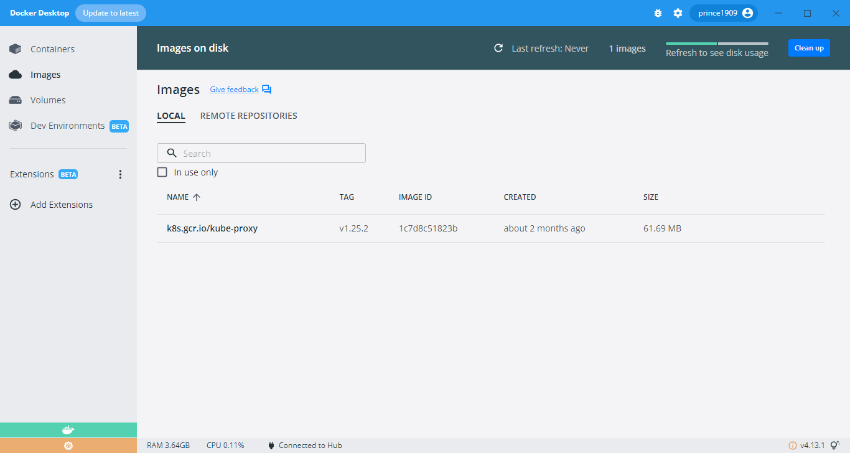

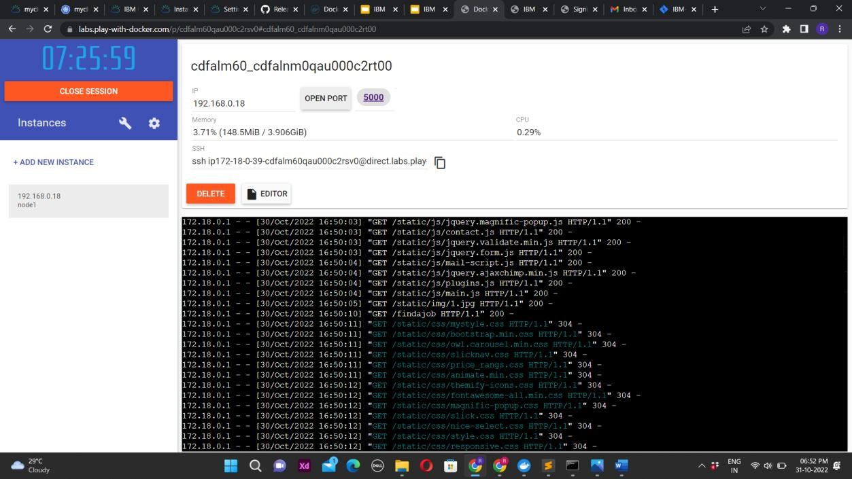

**Step 3**: Create a IBM container registry and push docker image of flask application or job portal app.

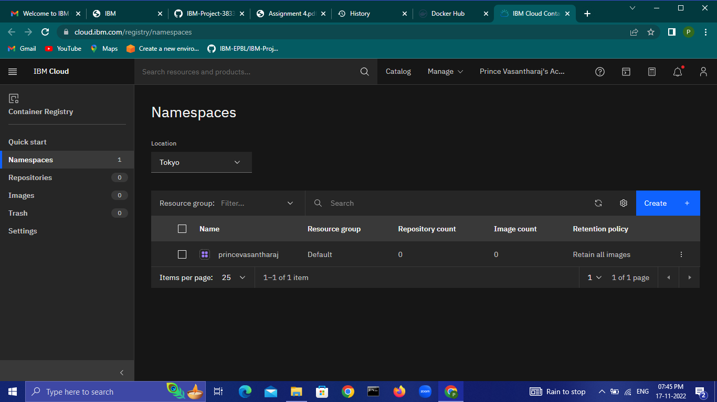

**Step 4**: Create a Kubernetes cluster in IBM cloud and deploy flask application image or job portal image and also expose the same app to run in Nodeport.

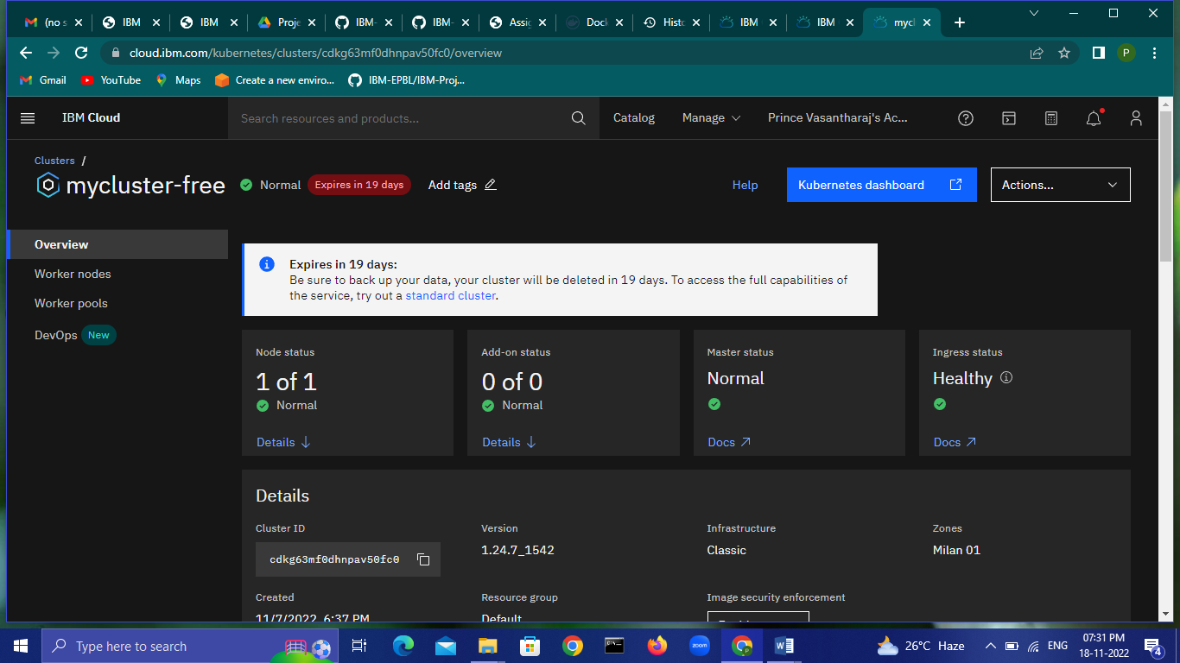

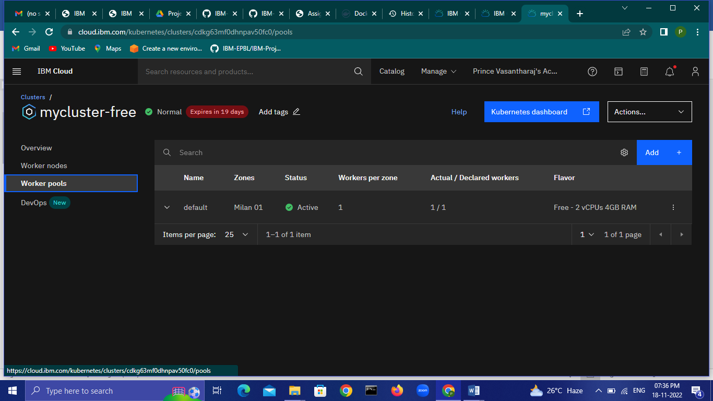

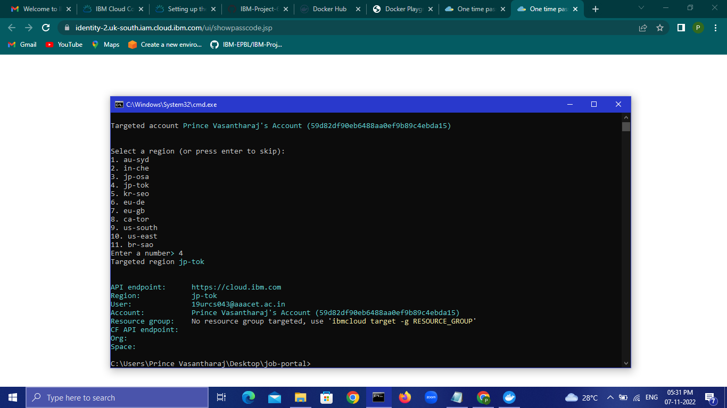

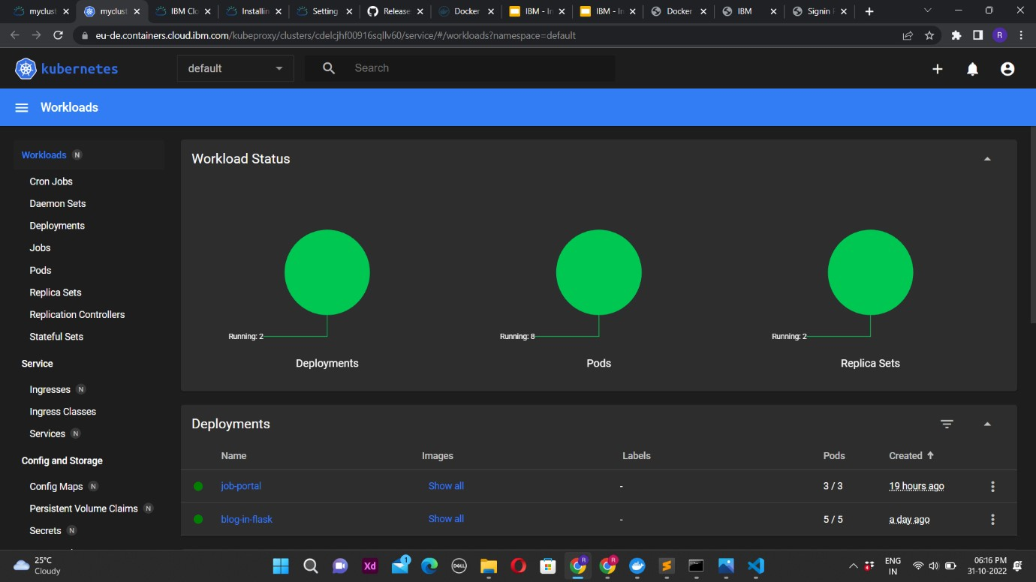

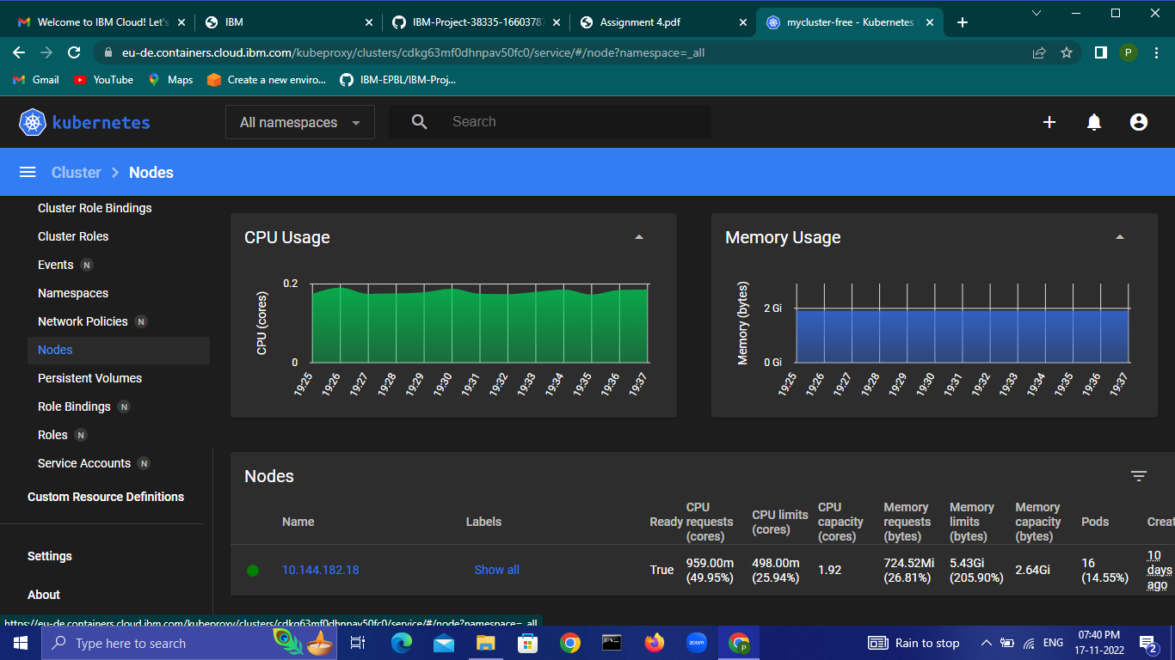

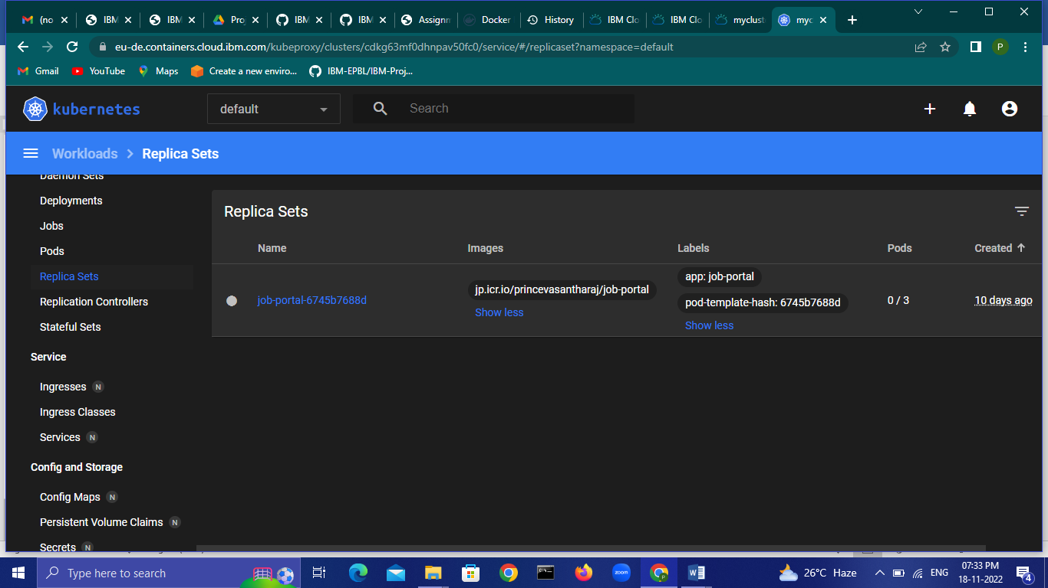

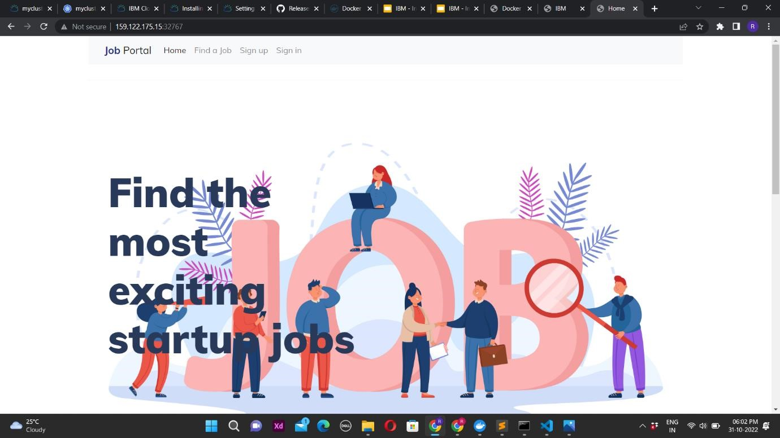

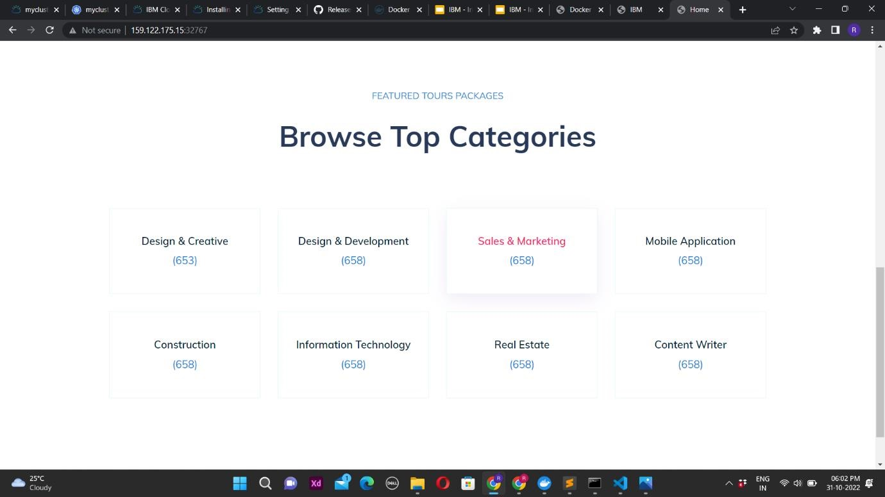

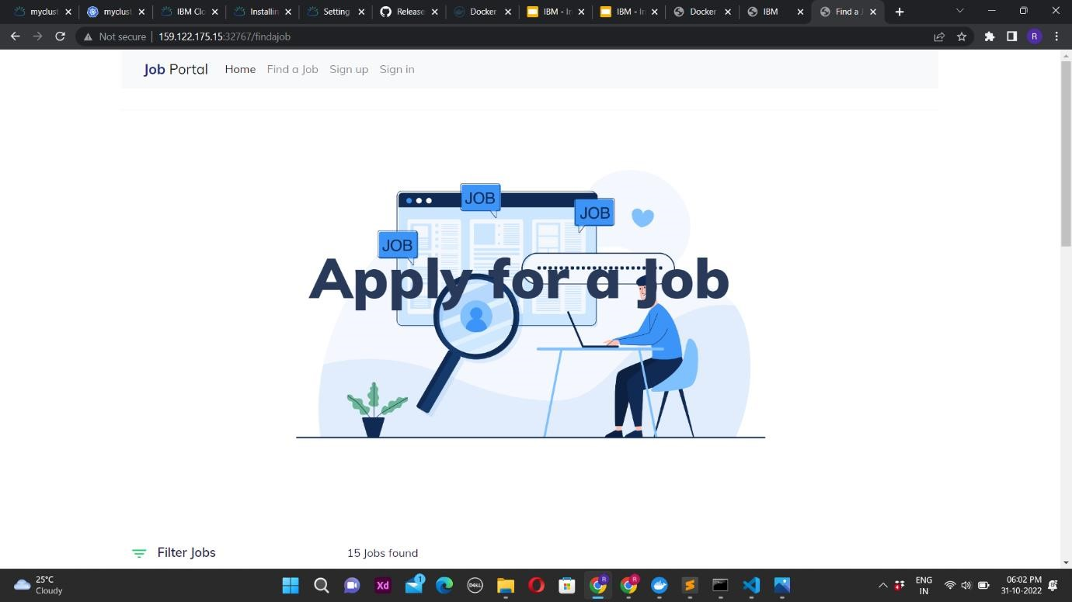

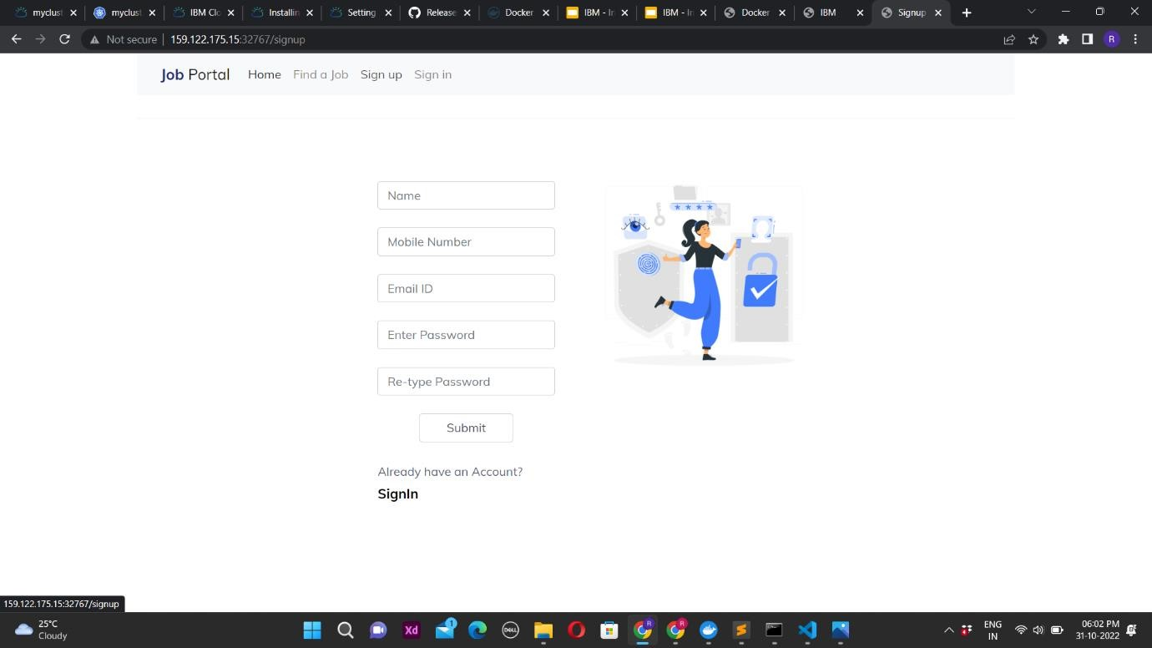

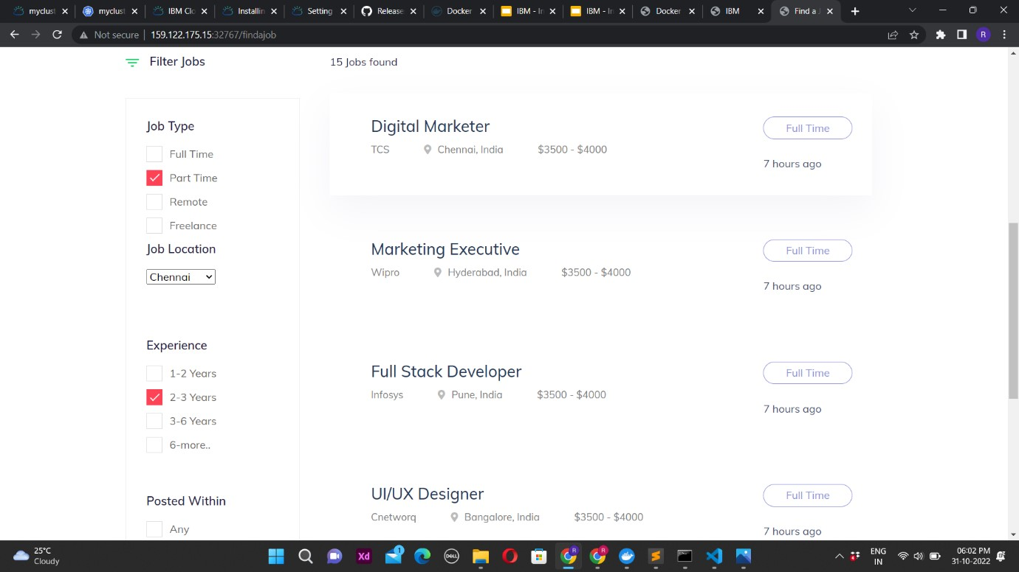

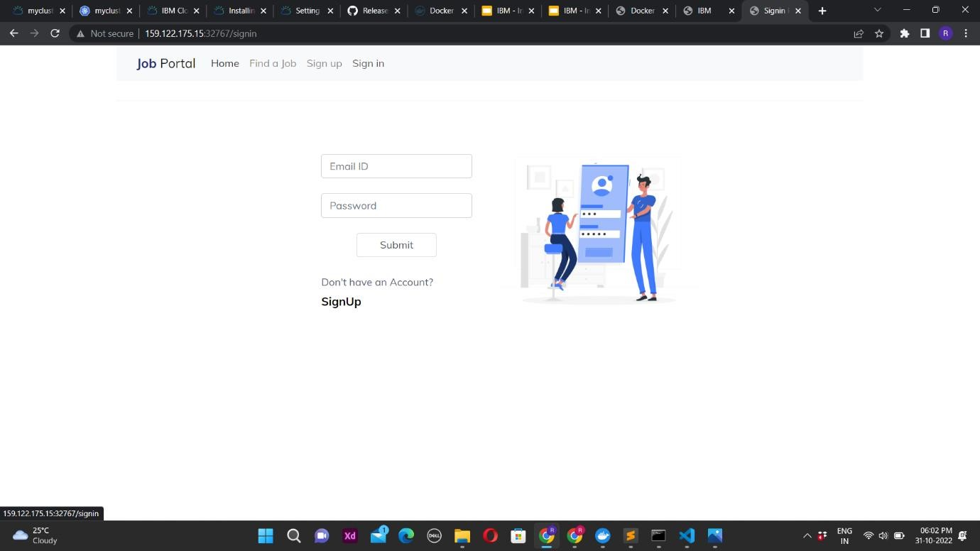

View the deployed Job-portal flask application by clicking the below link:

<http://159.122.178.141:30614/>